Login as FAS01.Student credentials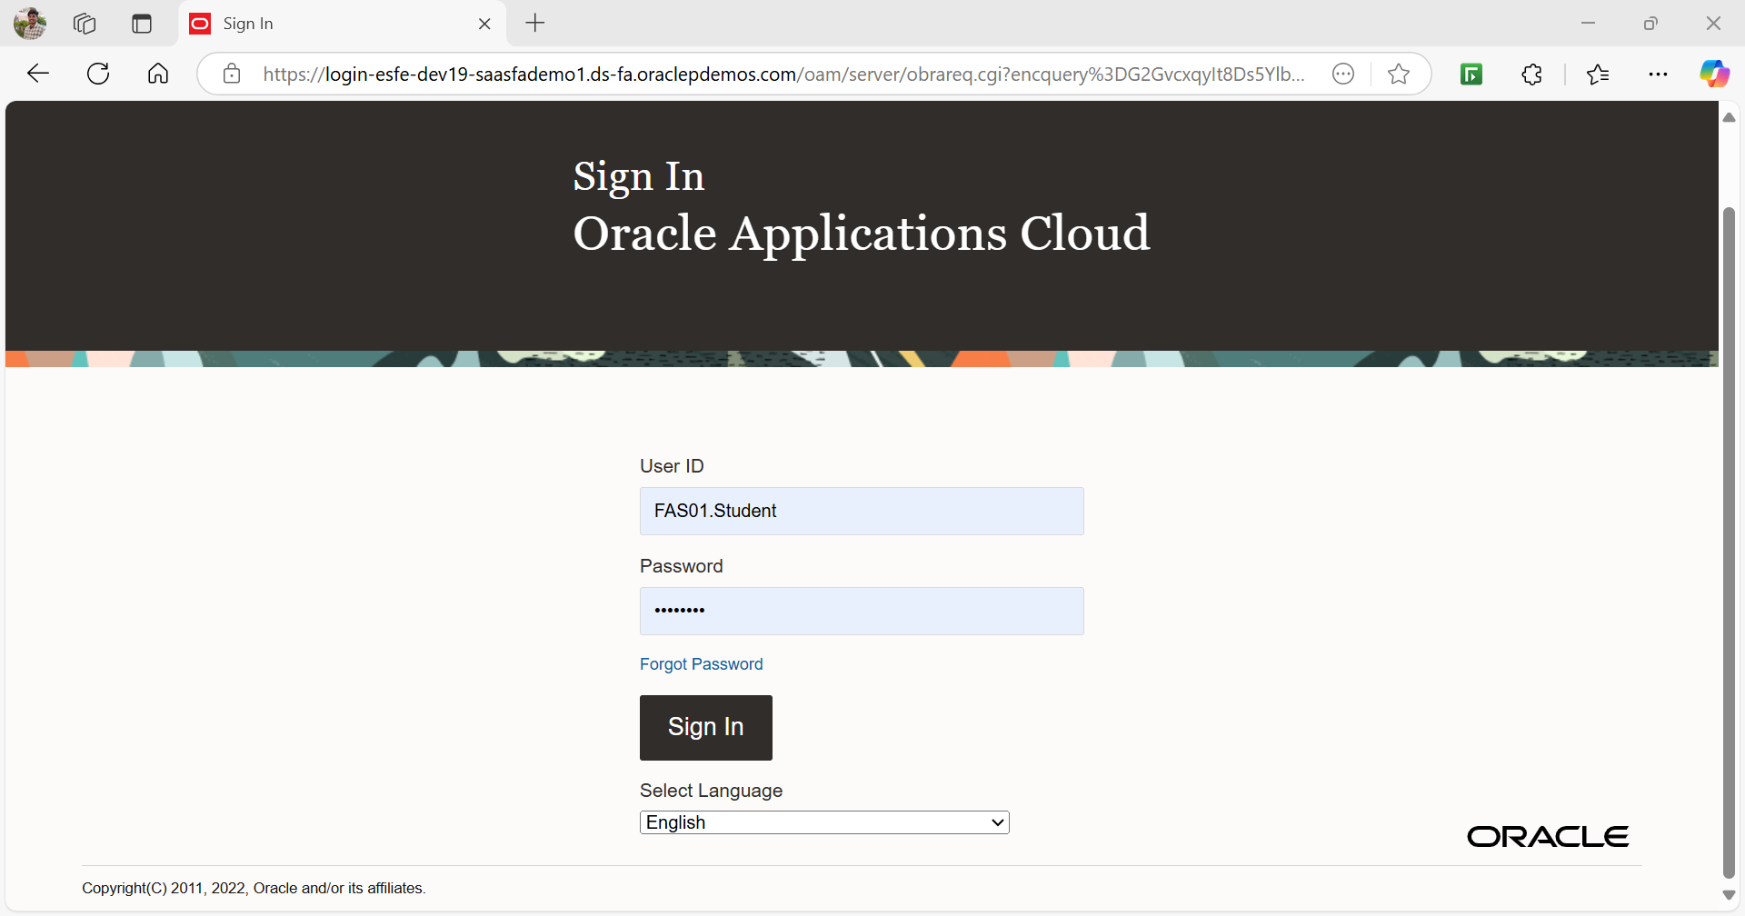  
  
Click on My Client Groups -> New Person  
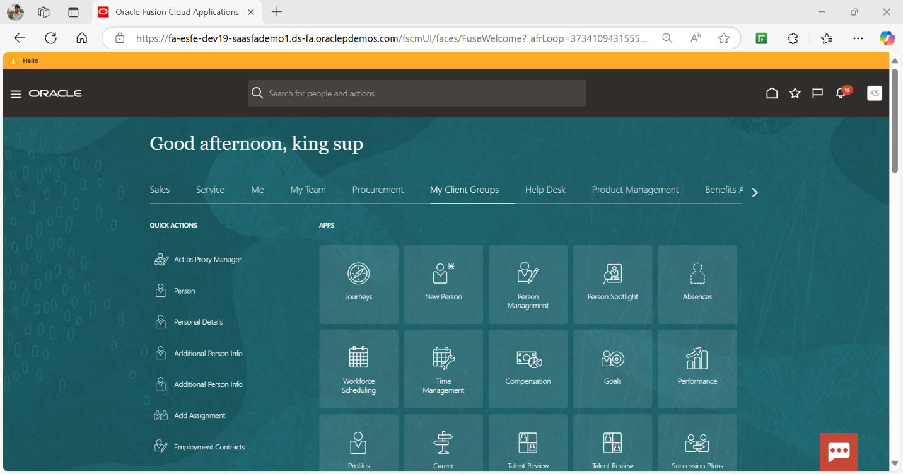

Click on Hire an Employee  
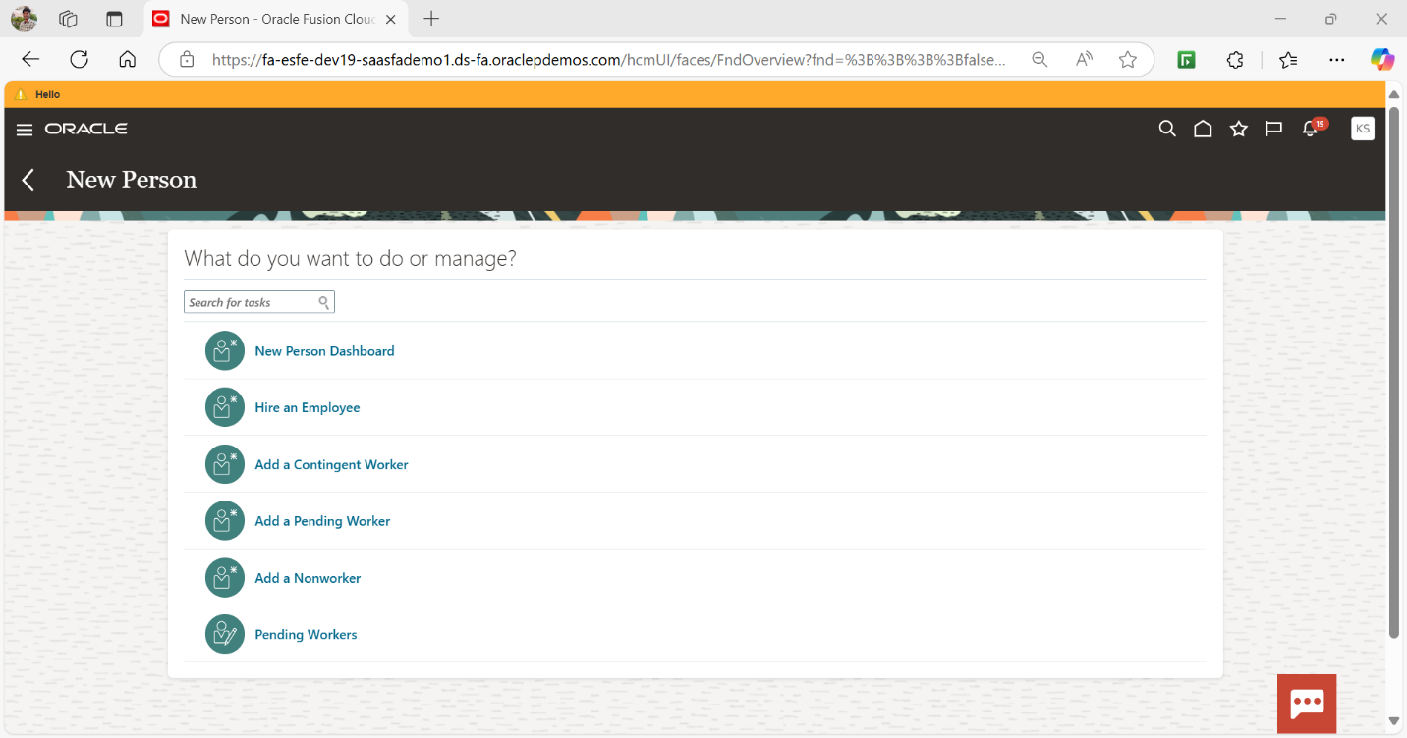

Enter the details in required fields  
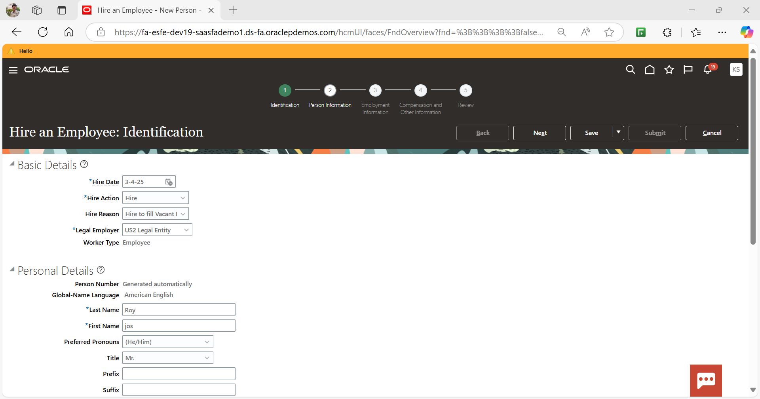

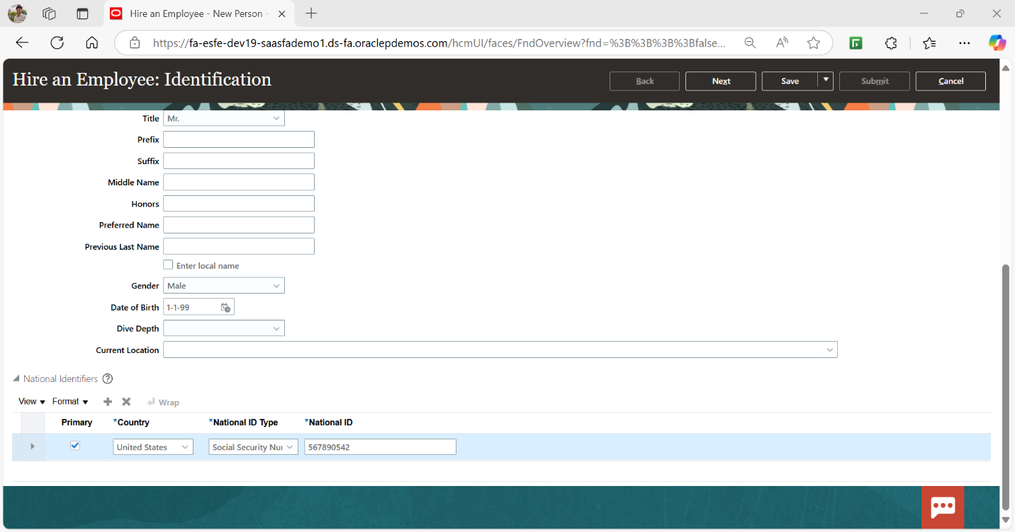

Click on Next to proceed to “Person Information” and continue on filling the Information  
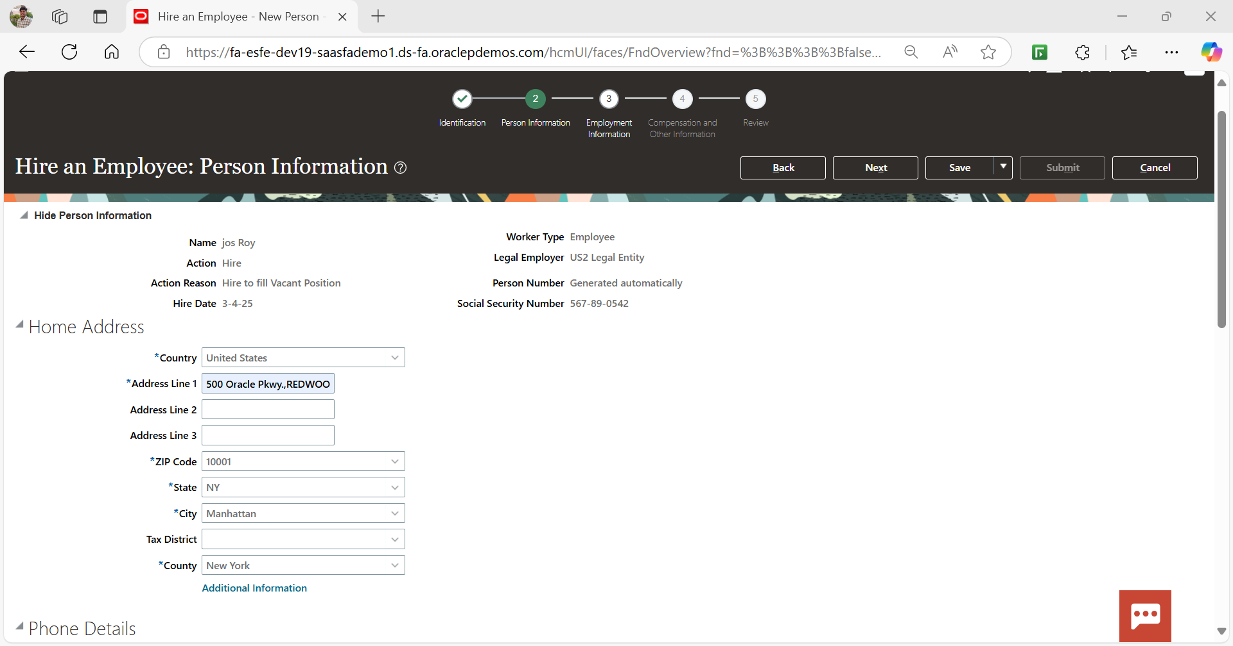

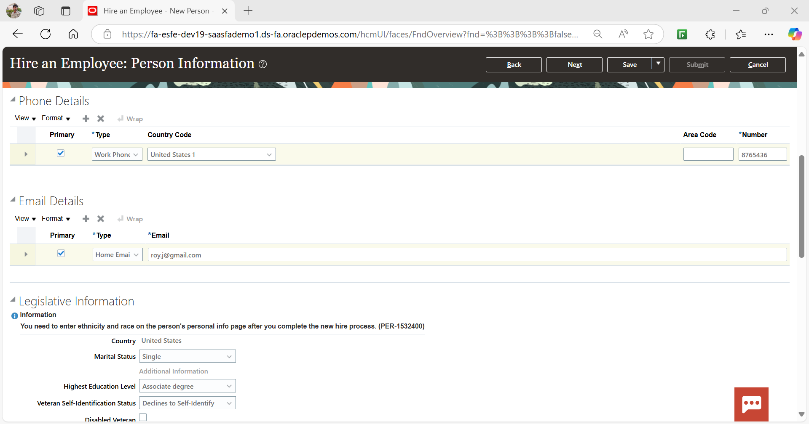

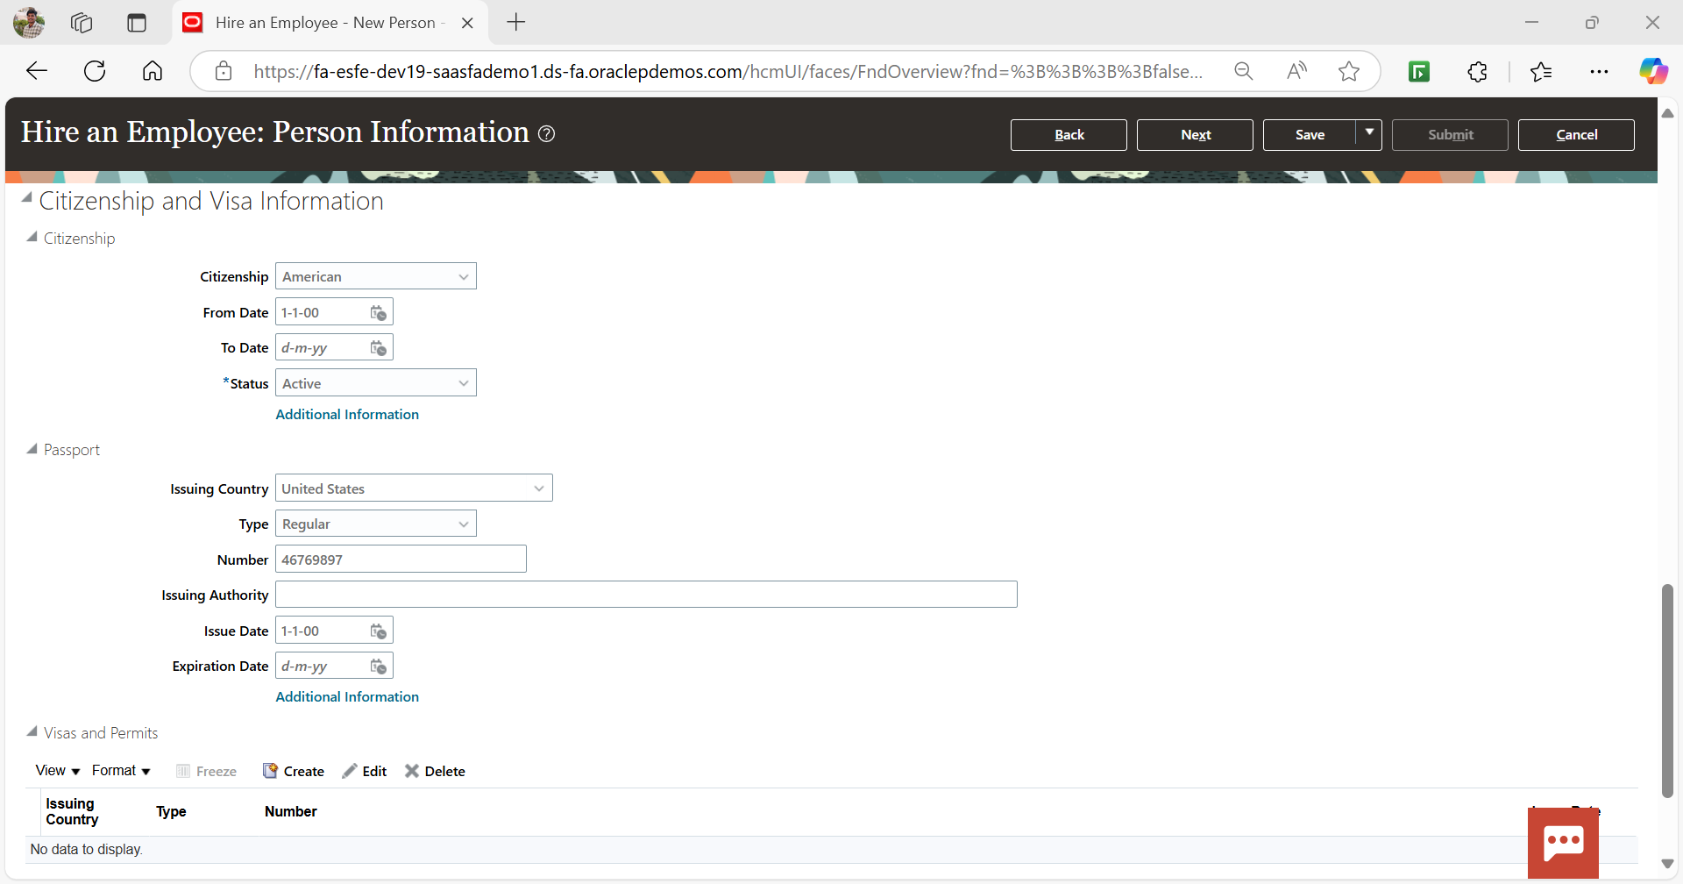

Click on Next to proceed to “Compensation Information” and continue on filling the Information

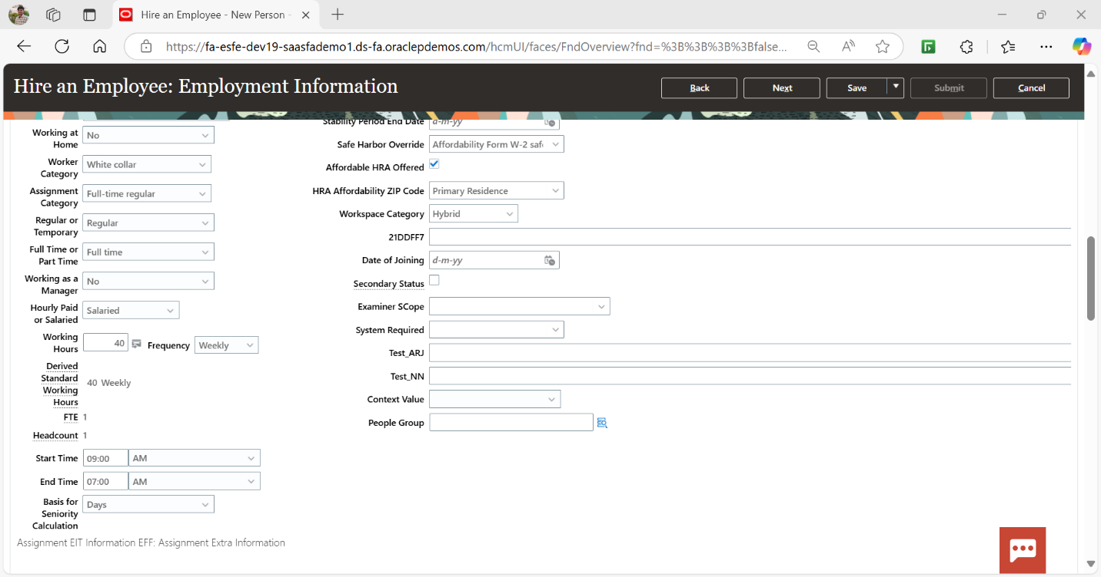

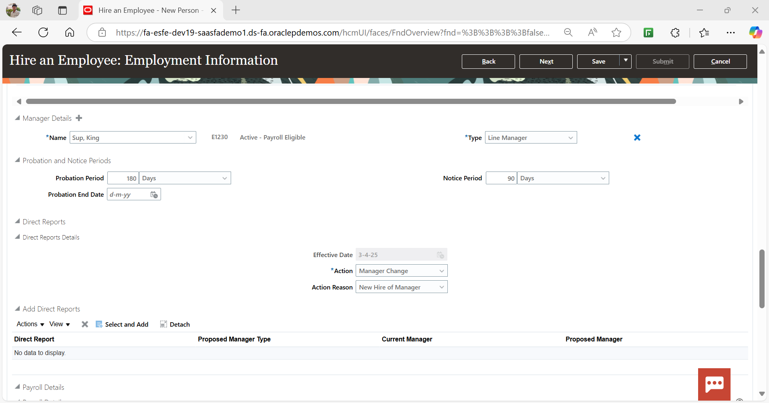

Click on Next to proceed to “Compensation and Other Information” and continue filling the Information

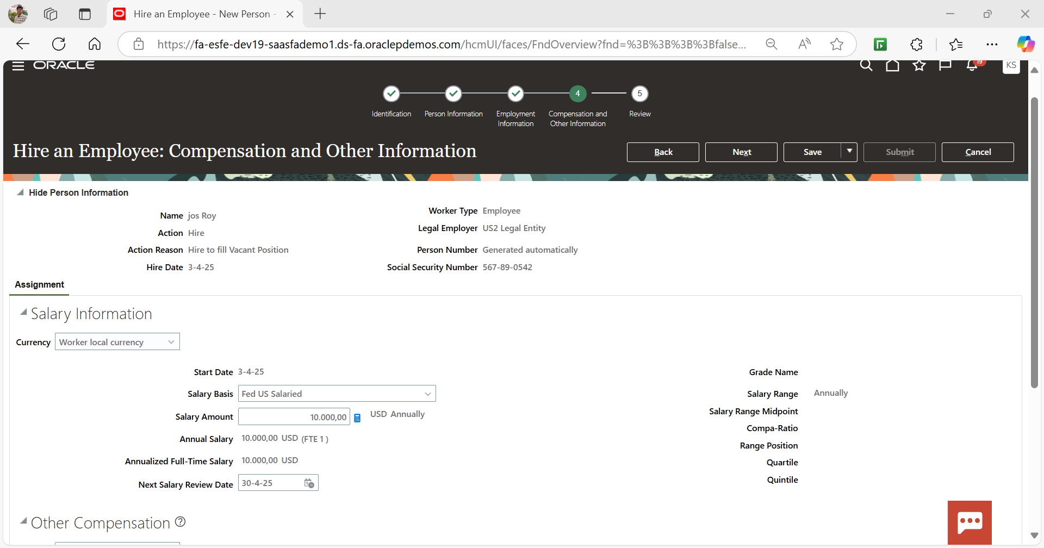  
  
Click on Next to proceed to “Review”, review & submit the Information

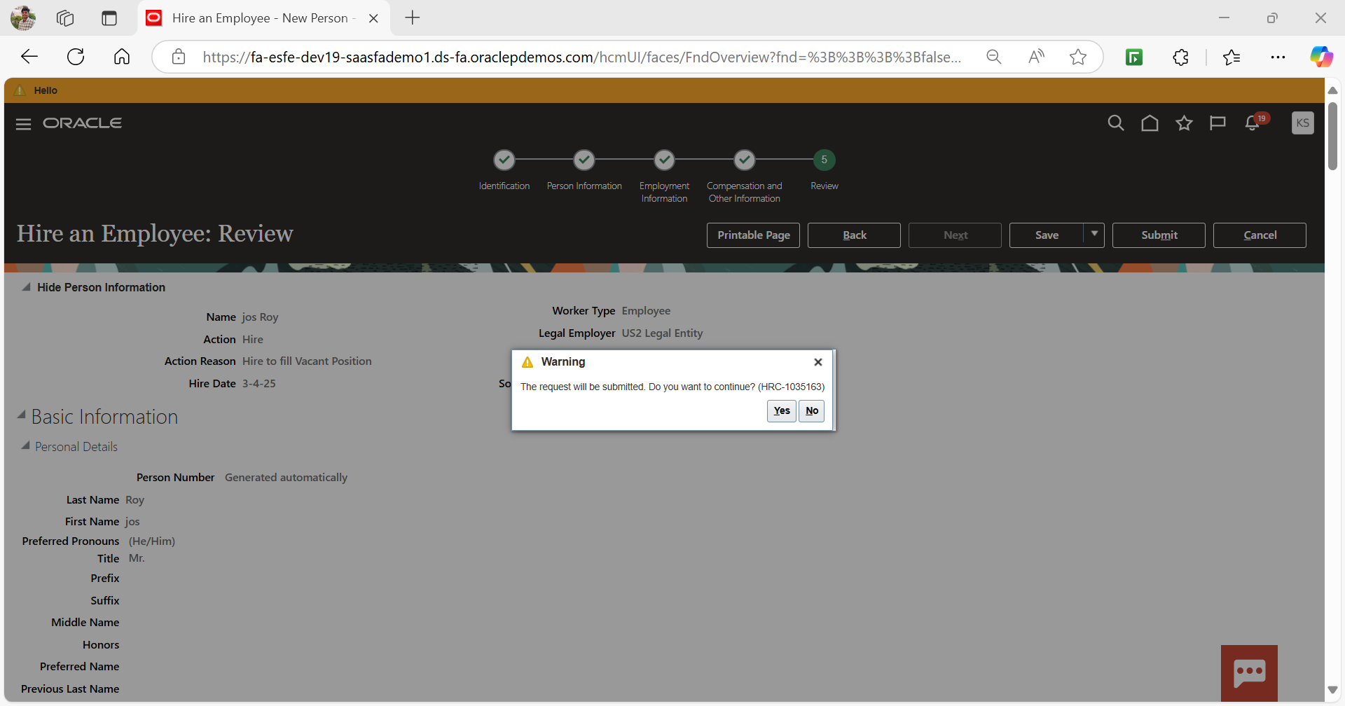

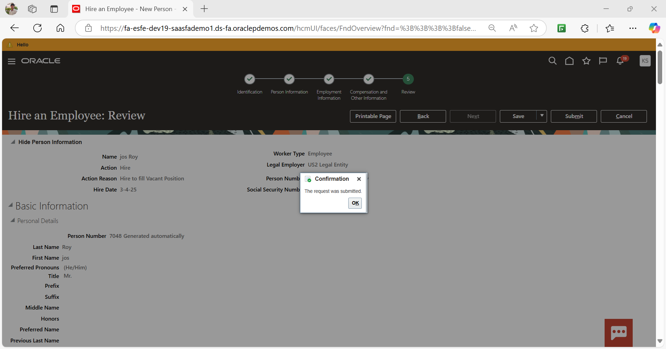

Click on Home   
Navigate to My Client Groups -> Person Management  
  
Search and open employee Information  
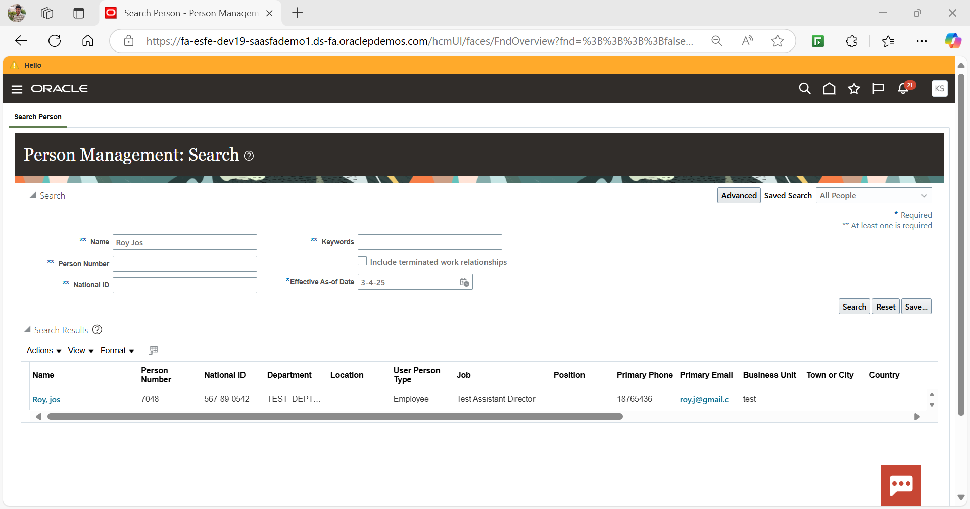  
  
Click on tasks -> Individual Compensation  
  
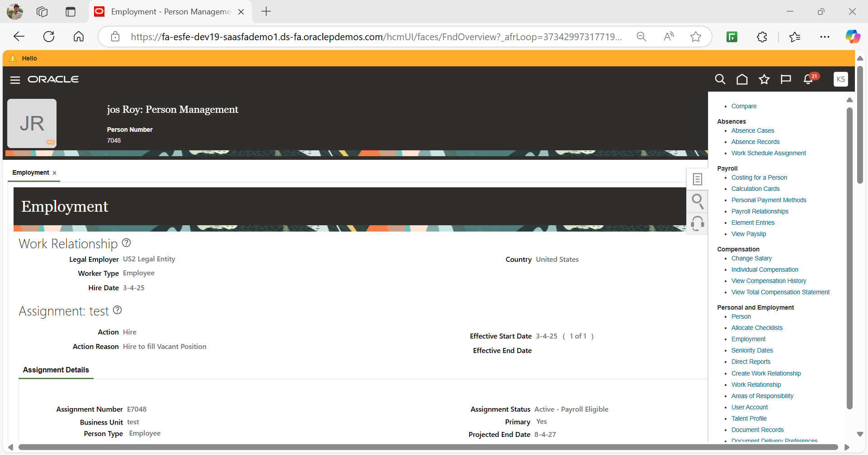

Click on award compensation and select plan  
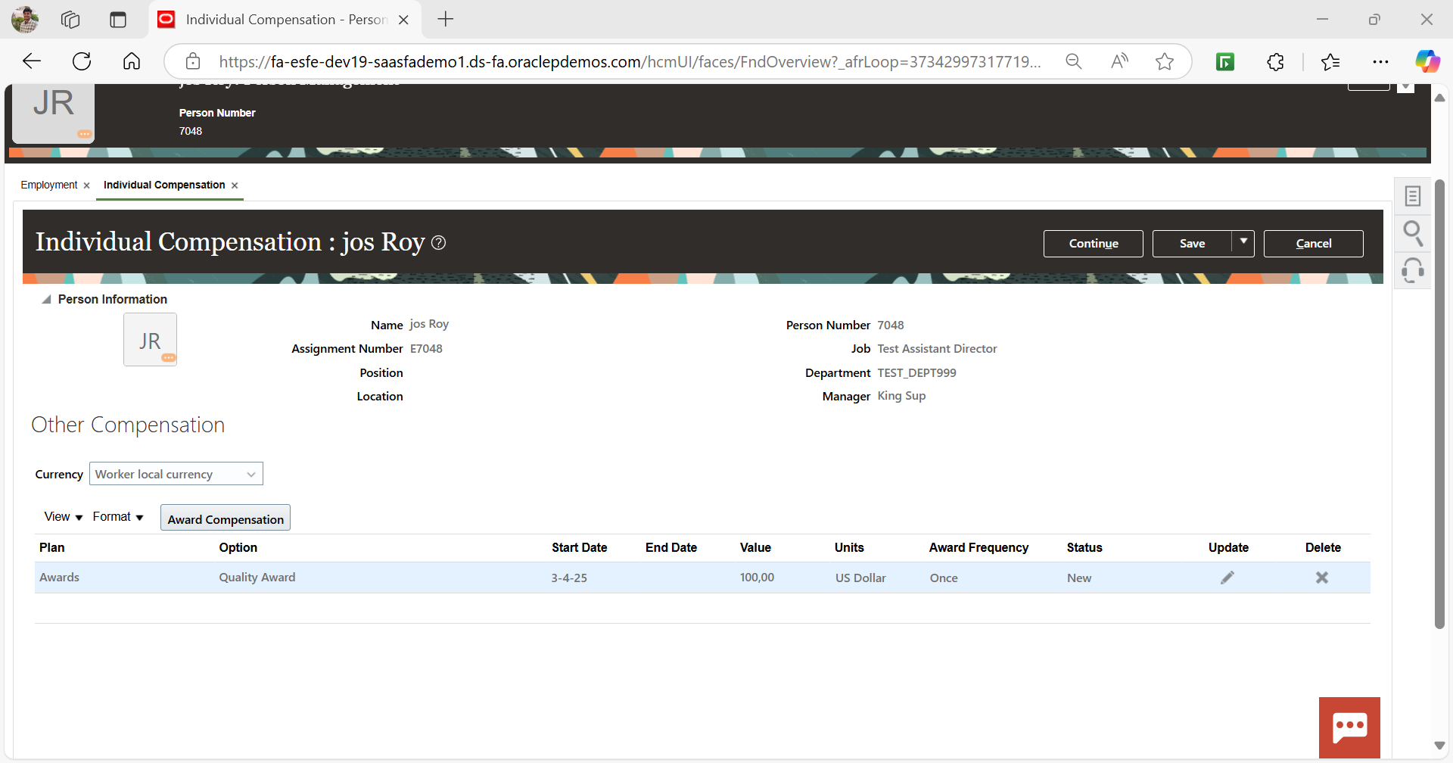

Click on continue & Submit  
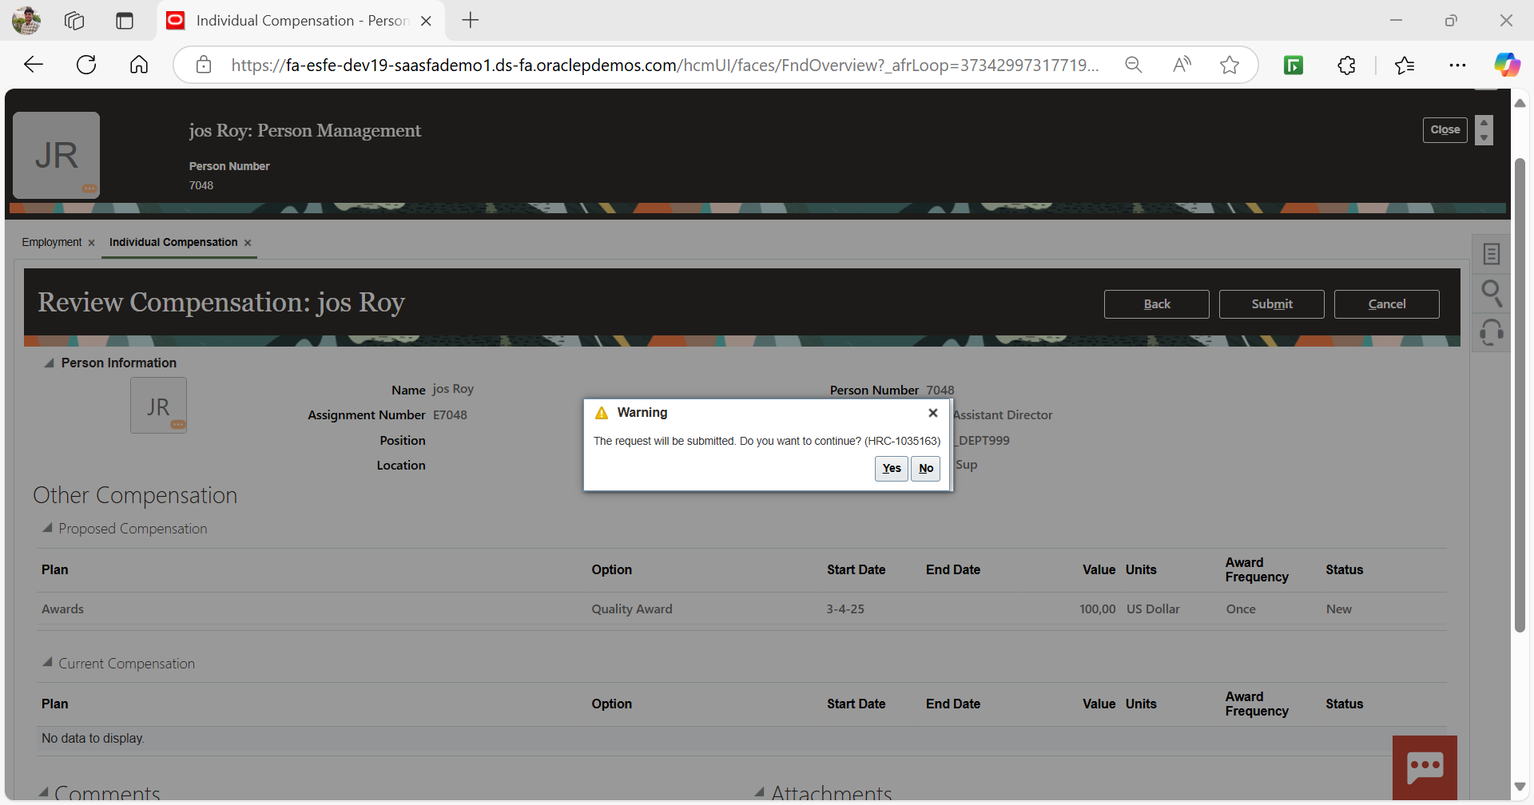  
  
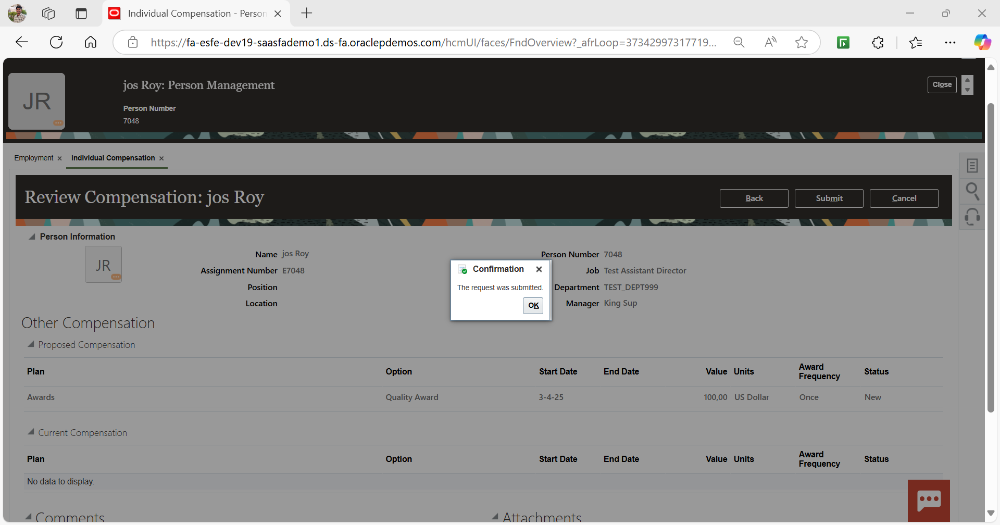  
Click on Tasks -> Individual Compensation and check the status  
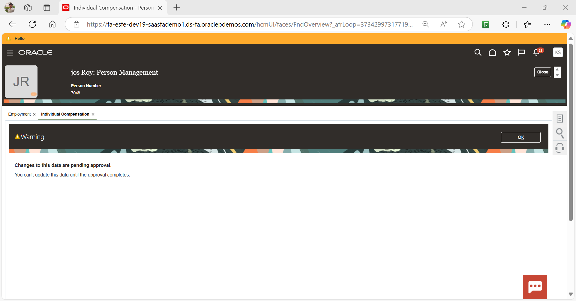  
  
Click on home  
Navigate to My client groups -> Compensation  
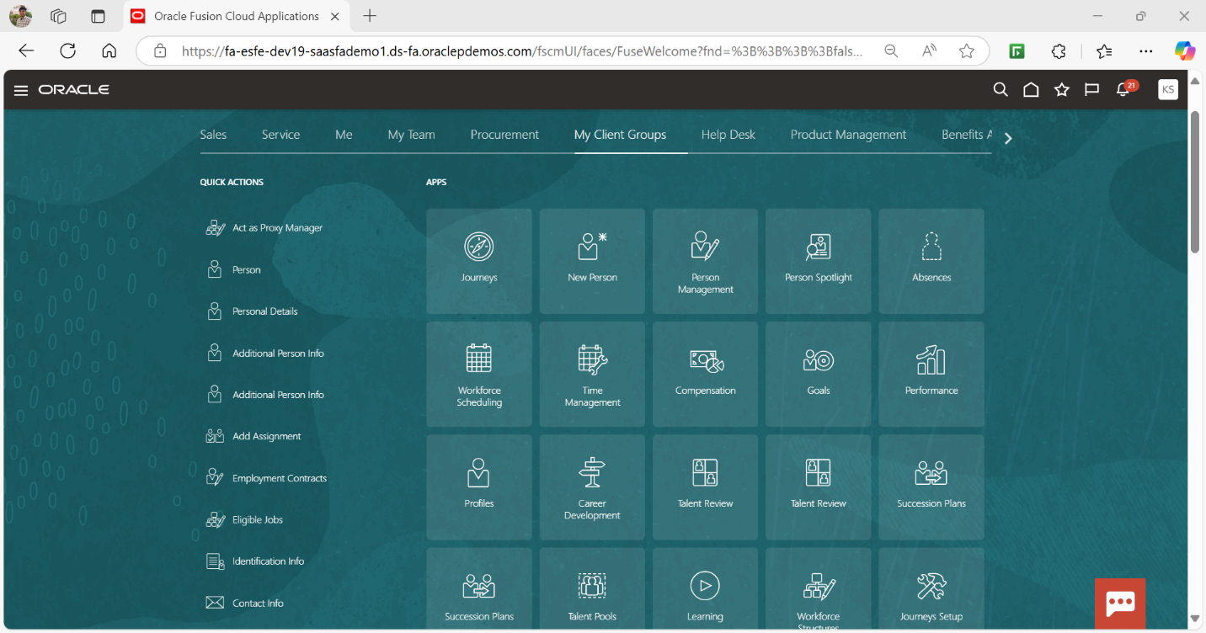  
  
Navigate to individual Compensation  
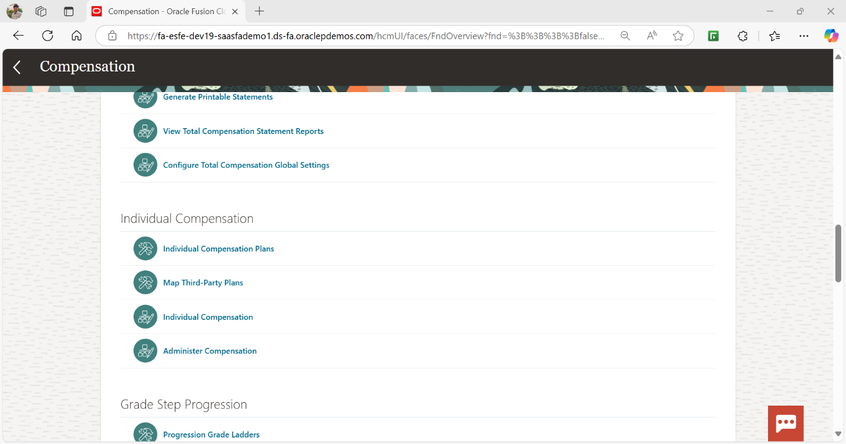  
  
Search with Employee details and find approver  
  
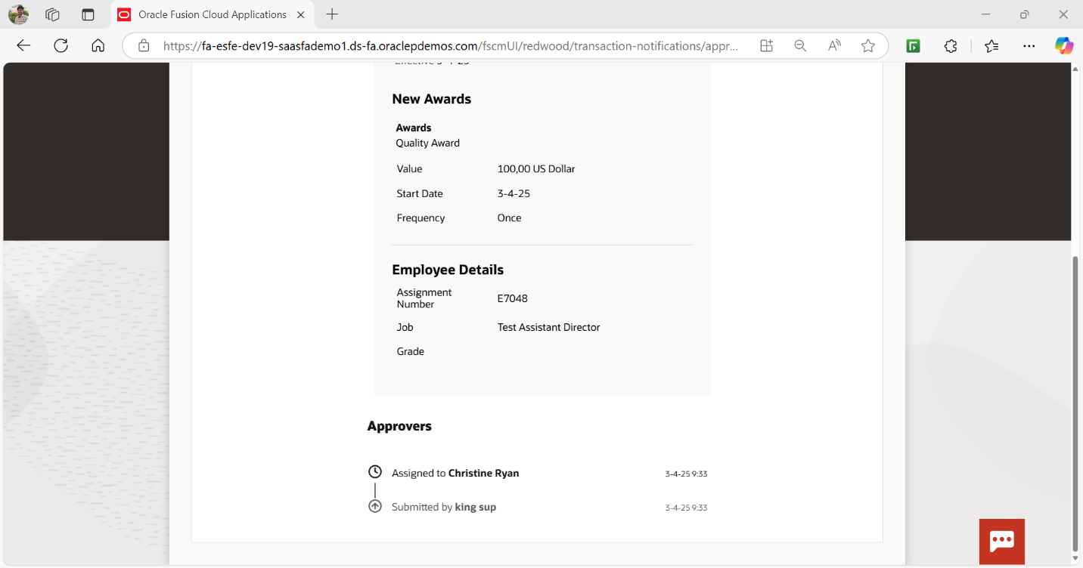  
  
  
  
Login with Approver credentials  
Usr :- CHRISTINE.RYAN  
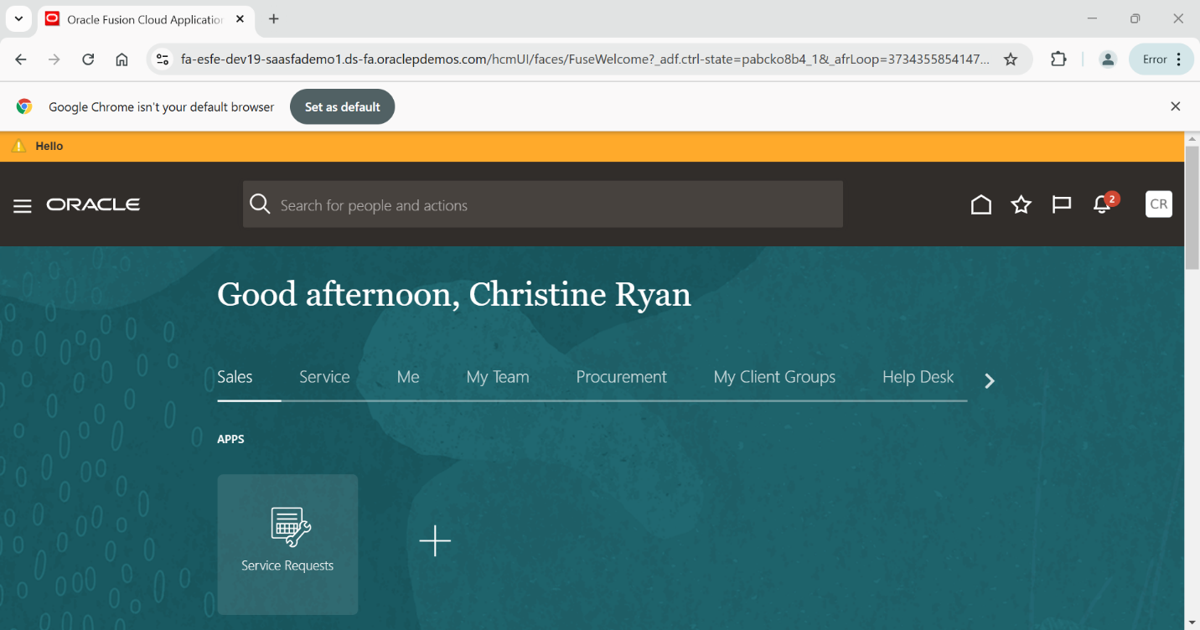  
  
Click on notifications  
  
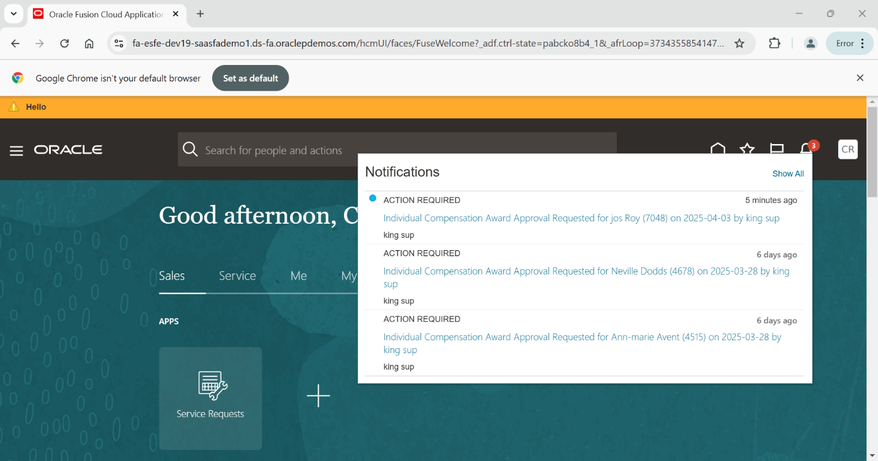

Open and approve the employee compemsation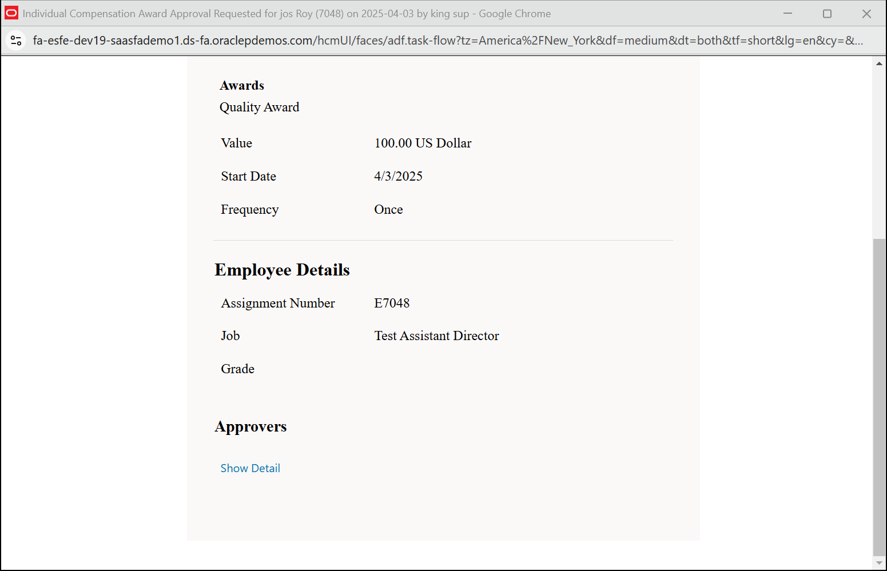

Click on approve  
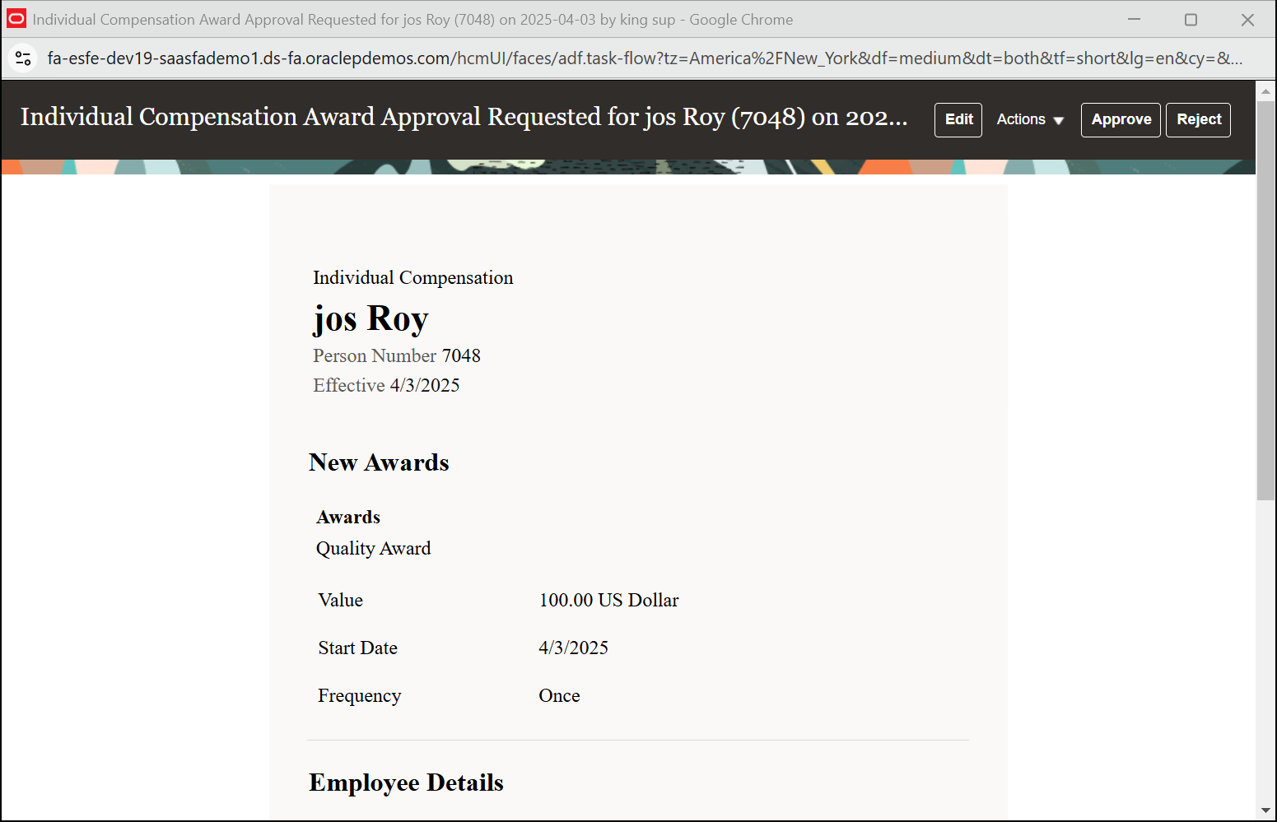  
  
  
Login as FAS01.Student and check the status  
  
Navigations My Client Groups -> Person Management  
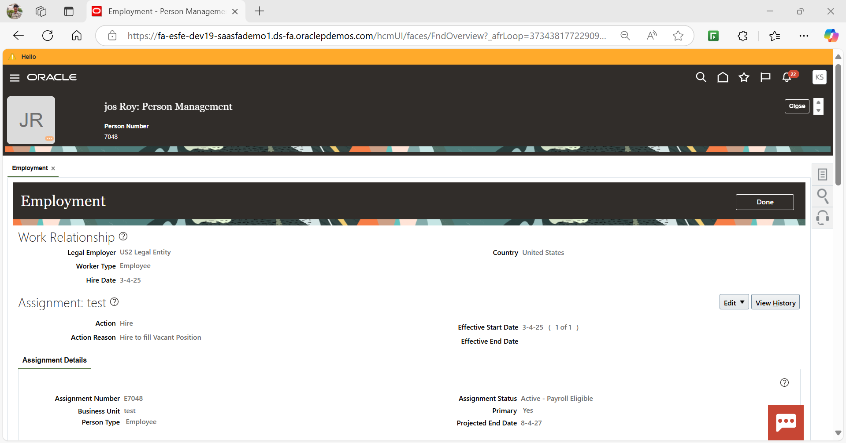  
Navigate to tasks -> Individual Compensation  
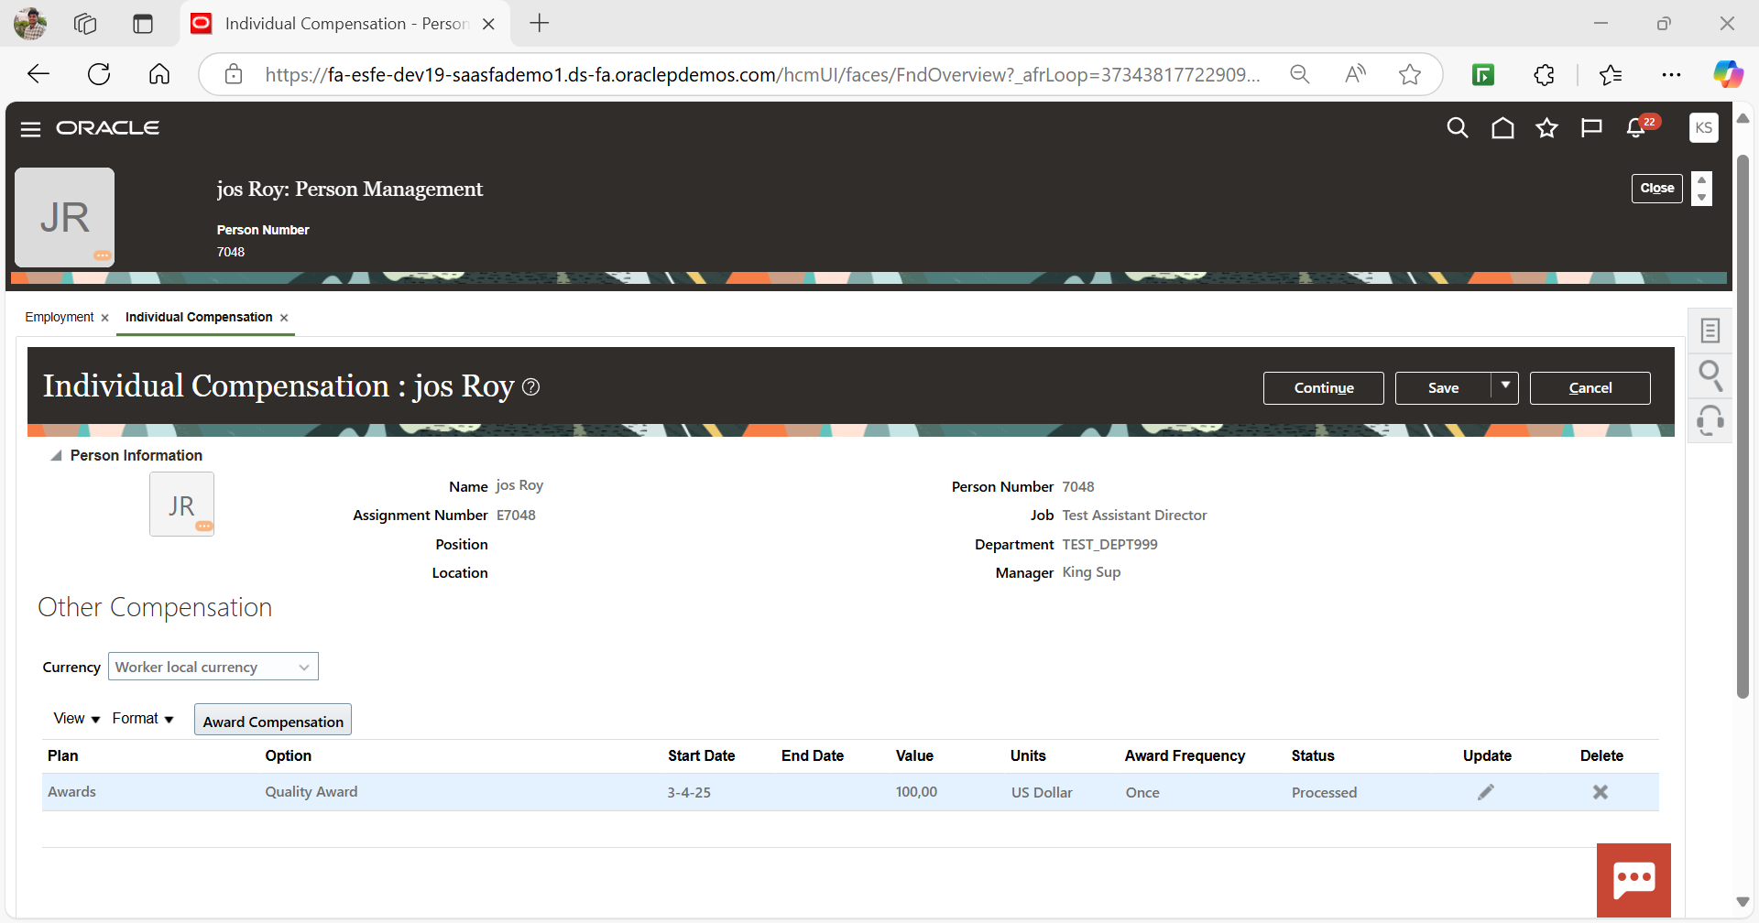  
  
Navigate to tasks – element Entries  
Check the plan in element name  
